Encrypted Virtual Private Network in Secure Internet of Things Technology

Rajaputhri Maharaja
Department of Computer Science
California State University, Los Angeles
Los Angeles, USA
rmahara@calstatela.edu
Prashant Krishnan Iyer
Department of Computer Science
California State University, Los Angeles
Los Angeles, USA
piyer@calstatela.edu

Nivethitha Subaschandrabose
Department of Computer Science
California State University, Los Angeles
Los Angeles, USA
nsubasc@calstatela.edu

Abstract—Internet of Things is a rapidly growing technology in the recent times. Security engineers come up with new detection and prevention methods to keep the Internet of Things secure. One of the important measures is to keep the internal functioning of the Internet of Things secure. Machine to Machine communication forms the base of Internet of Things technology. Machine to Machine communication has changed into a system of networks that transmits data to many personal appliances. MQTT is an extremely lightweight publish/subscribe messaging protocol for Machine to Machine communication. MQTT communications that rely on TCP alone are unencrypted and susceptible to man-in-the-middle attacks. In this paper, we propose to build an Encrypted Virtual Private Network to overcome the limitations in the security of MQTT protocol. This work incorporates building an Internet of Things architecture and configuring an MQTT Broker using Encrypted Virtual Private Networks. It also aims in performance evaluation in setting up a VPN server locally using Raspberry Pi and one setting on a cloud infrastructure.
Keywords—Internet of Things, MQTT, Encrypted Virtual Private Networks.

Introduction
The Internet of Things introduces a vision of a future Internet where users, computing systems, and everyday objects cooperate seamlessly.The IoT envisions hundreds or thousands of end-devices with sensing, actuating, processing, and communication capabilities able to be connected to the Internet. These devices can be directly connected using cellular technologies or they can also be connected through a gateway, forming a local area network, to get connection to the internet.
Machine to Machine communication forms the base of IoT architecture.The end-devices usually form Machine to Machine (M2M) networks using various radio technologies, such as ZigBee, Wi-Fi and many more. The data transfer patterns in the M2M-driven Internet of Things will differ fundamentally from those in the classic 'human-to-human' (H2H) internet. M2M communications will create low-bandwidth and upload biased traffic. The 'things' in the IoT, or the 'machines' in M2M, are physical entities whose identity or state is capable of being relayed to an internet-connected IT infrastructure.
Message Queue Telemetry Transport (MQTT) protocol is an extremely lightweight communication protocol that forms the base of M2M communicational architecture. It drops the need for using computational resources. It is an publish/subscribe messaging protocol unlike the request/response since messages need not be responded, thereby reducing the network bandwidth. MQTT ensures high reliability by providing Quality of Service at all levels.
A Virtual Private Networks (VPN) allows you to connect to the internet via a server run by a VPN provider. All data traveling between your computer, phone or tablet, and this “VPN server” is securely encrypted. In a VPN, the computers at each end of the tunnel encrypt the data entering the tunnel and decrypt it at the other end. However, a VPN needs more than just a pair of keys to apply encryption. The basic idea is to configure a “TLS/SSL” TCP port for the MQTT clients to use when connecting to the VPN.
Smokeping is a Network Latency Grapher and a latency visualisation tool. It can be used with Raspberry Pi to monitor the latency and data loss. It can be monitored on the hosts such as servers, workstations, switches, routers, access points and many more. In this research we will use Smokeping to monitor traffic for checking latency on servers’ setup using Raspberry Pi and the one set up on cloud.

related work
Early investigation of mitigation of the replay attacks and man-in-the-middle attacks on IoT were carried out by Namje Park and Namhi Kang [1] they proposed a system for mutual authentication and session key distribution that can withstand replay attacks and man-in-the-middle attacks. The proposed system enables inter-device authentication and the session-key sharing method for resource-limited devices that can use only symmetric-key-based encryption modules in MQTT based IoT architecture. However, the proposed system assumes that the devices involved securely share key. If key is compromised, there is a limit to the security that can be guaranteed by the proposed system. Like many existing proposed systems using preset secret keys, in this paper, the proposed system assumes secure channels and storage methods. However, further research is required to realize the secure sharing of key. This is a drawback since there is no secure channel for key exchange and data flow, since it only focuses on making the encryption strong. Our proposal aims at building up an encrypted VPN (secure network) for protecting the IoT end devices and the data transfer.

encrypted virtual private network
Security in IoT is the most crucial aspect. There are many techniques to secure end devices and the data in an IoT. Encrypting data and using a combination of different protocols are some of the solutions to securing IoT. Although these techniques may seem essential to ensure data protection, top priority should be given on building a secure network for IoT. An Encrypted VPN is one of the solutions for a secure network. By using an encrypted VPN we can contribute considerably in safety and trusty operations of the IoT connected devices. Tunneling is one of the mechanisms that is used in VPN’s to connect the end devices in the network to the server. It is very essential that the tunnel needs to be fully secured and well encrypted, since it is very vulnerable to attacks. Eavesdropping and Man-in-the-middle attacks are some of the potential attack scenarios possible if the VPN’s are not encrypted or if we do not use an Encrypted VPN.
This research aims in proposing an Encrypted VPN model to contribute to a strong IoT infrastructure and protect the IoT from replay attacks, eavesdropping and man-in-the-middle attacks.
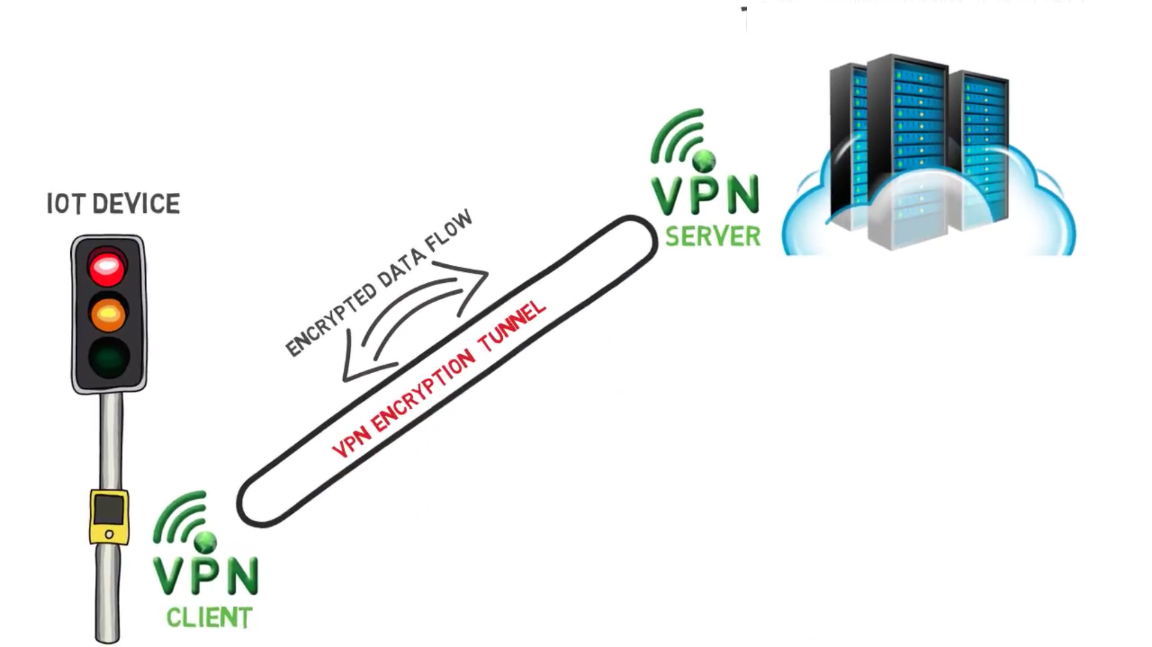
Fig.1. Encrypted VPN Model

Propsed Model
Our proposed system includes setting up an infrastructure for IoT using Raspberry PI and Mosquitto. It aims in setting up a VPN server using Raspberry Pi and a VPN server infrastructure in a cloud. The research aims in providing a detailed summary of the difference in latency for the requests to get processed when the VPN server is setup on the Raspberry Pi vs on a cloud.
The proposed system also aims in building up three models. First model would have all the requests processed by the local Raspberry Pi server.

Latency
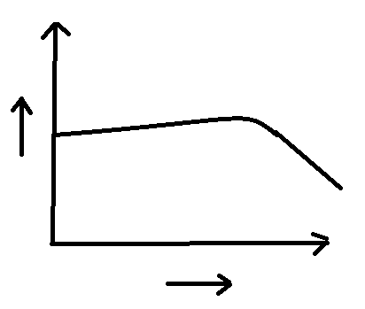
Number of requests
Fig.2. Proposed latency in local Raspberry Pi server.

The second model would have the requests to be processed in the cloud. When deploying a solution in cloud, the cloud environment could be, and almost definitely is going to be many miles away. Hence the higher the latency it will possess as the number of requests gradually increase.

Latency
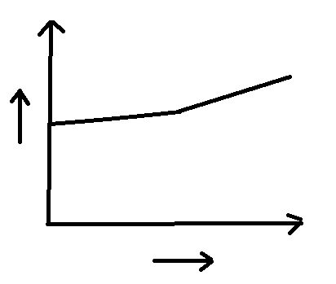
Number of requests
Fig.3. Proposed latency in cloud server model.

The third model would be a hybrid model with higher order requests (in terms of processing speed and complexity) are to be processed in the Raspberry Pi so that there would be less overhead of processing time and handling complex objects. The requests with less overhead are to be processed in the cloud.

Latency
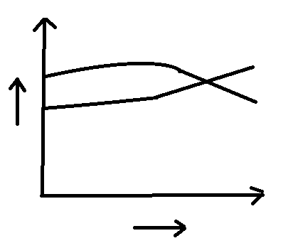
Number of requests
Fig.4. Proposed Latency in hybrid server model.

Latency is one of the key metrics to be checked on the servers. The proposed plan checks for the performance of the system when the server is configured locally vs when it is configured remotely on cloud. Also the encryption time plays an important role when the servers are configured locally vs remotely. Other important performance metrics include bandwidth of the connection, contention ratio, load of the server we are connecting to and the nature of storage devices on the infrastructure. The estimated cost of the project is around 100-150$. Our team has started with the implementation of configuring local Raspberry Pi servers and designing the infrastructure for the IoT. The hybrid model proposed if implemented effectively can be a great model for building up private local VPN servers, thus providing a solution for decrease in latency and overhead cost, thus putting less load on cloud infrastructures.

Performance Evaluation
This section describes the performance evaluation methods of our proposed system. Latency calculation and the Bandwidth calculation forms the basis of performance evaluation in our proposed system.
The term Latency refers to any of several kinds of delay typically incurred in the processing of network data. Besides propagation delay, latency may also involve transmission delays and processing delays such as network hops. End-to-End latency deals with the delay before a transfer of data begins following an instruction for its transfer. Our proposed system calculates end-to-end latency that is the time taken for the subscriber to receive response from the publisher after the subscriber requests for a particular topic (say environment/temperature).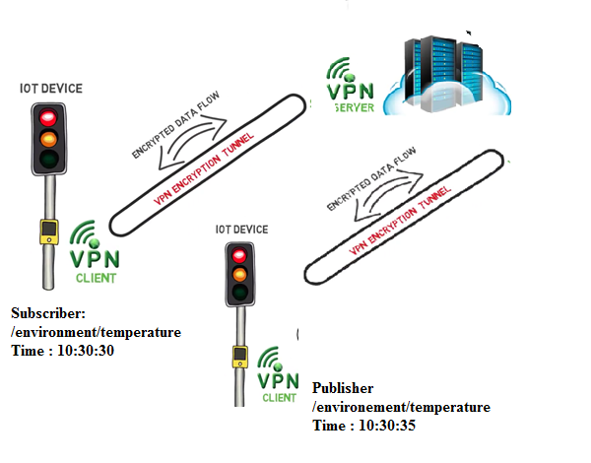
Fig.5. Encrypted VPN model showing end-to-end latency.

The above figure demonstrates how the end-to-end latency is actually calculated when a subscriber subscribes for a topic at time t1 and when the publisher publishes the message at time t2.The publisher sends its publishing time t2 with the message payload to the MQTT broker which in turn sends the payload to the subscriber who subscribed for the particular topic. Then the subscriber calculates the end-to-end latency by calculating the absolute of time difference between its subscription time t1 and the publishing time t2.

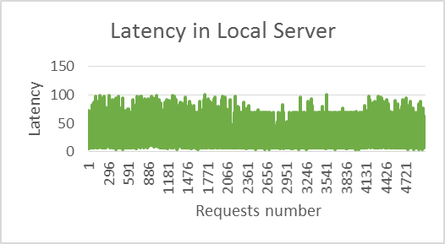
Fig.6.a Latency achieved in the local sever
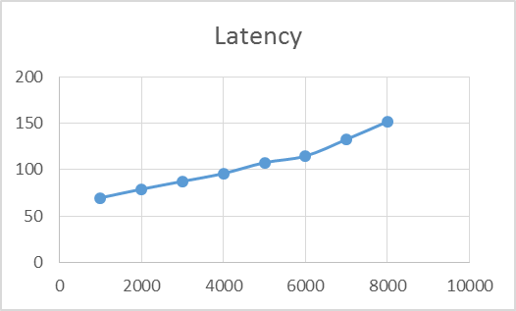
Fig.6.b Latency achieved in the local sever

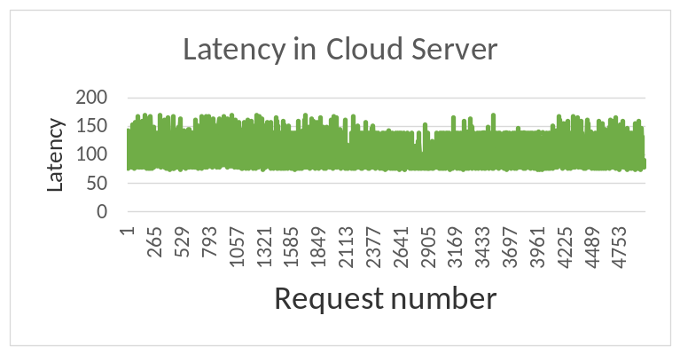 Fig.7.a Latency in cloud server.

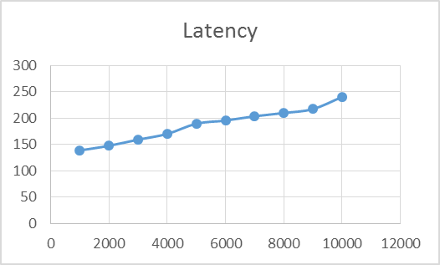
Fig.7.b.Latency in cloud server.

The above Figures 6.b and 7.b clearly depicts the difference in Latency patterns when considering requests to be sent through the local Raspberry-Pi server and the requests to be sent through the cloud server.
In Figure 6.b, the maximum threshold attained is 10.85mbps bandwidth utilization which could be the bandwidth of the line for the local Raspberry Pi server. In Figure 7.b, the maximum threshold attained is 8.56mbps bandwidth utilization which could be the bandwidth of the line to the cloud server.

In computer networks, bandwidth is used as a synonym for data transfer rate, the amount of data that can be carried from one point to another in a given time period (usually a second). Network bandwidth is usually expressed in bits per second (bps); modern networks typically have speeds measured in the millions of bits per second (megabits per second, or Mbps) or billions of bits per second (gigabits per second, or Gbps).
Bandwidth is defined as the ability to transfer data (like Json, VOIP call) from one point to another in a fixed amount of time. The Bandwidth needed for data transmission in M2M communication depends on a few factors namely, Packet overhead, Network Protocol used. (In this case MQTT, TCP-IP) and alsoOverhead due to compression technologies if any used.
For Example: If latency = 10ms (For one data packet request), 100 such data packet requests are required to be transmitted every second. Each packet carries network protocol overheads.
For Bandwidth calculation in M2M communication we also need to keep into account, the overhead of MQTT of the data to be sent, TCP to the MQTT packet, TCP to the data sent.
And not taking into account, the connectivity, keep alive and many more aspects.
TCP/IP header size = 40 bytes.
For Instance: Data size = 1Byte, 1Bytes * 40Bytes = 40Bytes = 4100% TCP/IP overhead, that is 41Bytes of data is actually transmitted.
For example: If we are sending 1000 requests per second, the size of the packet would be 164kb (JSON payload) + 42kb (MQTT Protocol overhead, PSH, ACK, TCP/IP Protocol overhead, MQTT header size, TCP/IP header size) that is 206kb, with a latency of say 69.564ms, then the bandwidth utilization rate would be 2.96mbps. Likewise, if we keep increasing the number of requests, there will be a proportionate increase in data size and at one point of time there will be a threshold of network bandwidth utilization, which would be the network bandwidth.
Number of Requests | Latency (in ms) | Size (in kb) | Bandwidth Utilization (in mbps)
1000 | 69.564 | 206 | 2.96
2000 | 78.891 | 412 | 5.22
3000 | 87.343 | 618 | 7.02
4000 | 95.833 | 824 | 8.59
5000 | 107.544 | 1030 | 9.57
6000 | 114.639 | 1236 | 10.69
7000 | 132.644 | 1442 | 10.92
8000 | 151.792 | 1648 | 10.85

The above results shows the behavior of local Raspberry-Pi server that a threshold is attained in bandwidth utilization, even after there is a gradual increase in the number of requests, but there is a gradual increase in the latency too.

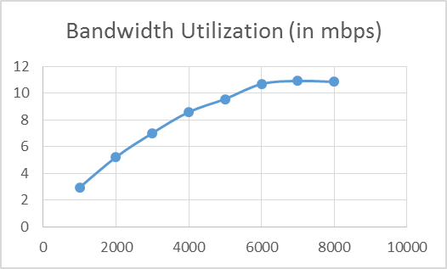
Figure 8.a Bandwidth Utilization in Local Raspberry Pi Server

The Figure shows that the bandwidth of the local Raspberry-Pi server is close to 10.85mbps, since even after gradually increasing the number of requests, there is no gradual change in the bandwidth utilization.

Number of Requests | Latency (in ms) | Size (in kb) | Bandwidth Utilization (in mbps)
1000 | 138.806 | 206 | 1.48
2000 | 147.678 | 412 | 2.78
3000 | 159.343 | 618 | 3.79
4000 | 170.233 | 824 | 4.64
5000 | 189.564 | 1030 | 5.43
6000 | 195.592 | 1236 | 6.31
7000 | 203.721 | 1442 | 7.07
8000 | 209.846 | 1648 | 7.85
9000 | 217.342 | 1854 | 8.53
10000 | 240.495 | 2060 | 8.56

The above results shows the behavior of Cloud server that a threshold is attained in bandwidth utilization, even after there is a gradual increase in the number of requests, but there is a gradual increase in the latency too.

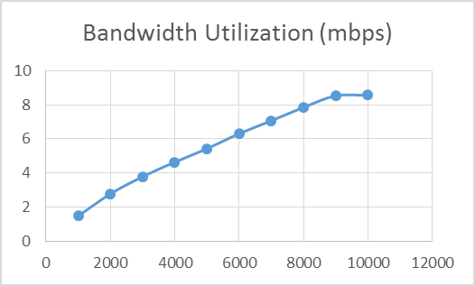
Figure 8.b Bandwidth Utilization in Cloud Server

The Figure shows that the bandwidth of the Cloud server is close to 8.56mbps, since even after gradually increasing the number of requests, there is no gradual change in the bandwidth utilization.

In the Hybrid mode, we have kept bandwidth utilization as the threshold factor responsible for load balancing. We will be sending all the payload to the cloud server for processing the subscriber (client) requests. As soon as the requests marks the threshold bandwidth utilization limit for the line, we will be directing half the packets (half the load) to the local Raspberry-Pi server that will have a better bandwidth limit, since it would have lower latency and less traffic to deal with as compared to the cloud server.

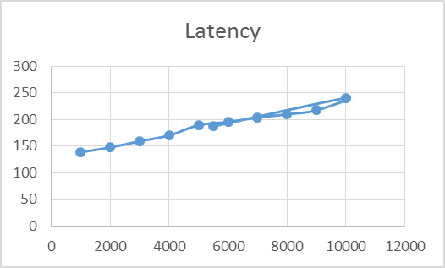
Figure 9.a Latency in Hybrid Mode

As shown in the figure, the latency will gradually decrease by splitting the requests between the cloud server and the local Raspberry Pi server. Since the load decreases, the latency decreases, giving better throughput overall.

Number of Requests | Latency in Cloud server | Number of Requests | Latency in Local Server
1000 | 138.806 | 1000 | 69.564
2000 | 147.678 | 2000 | 78.891
3000 | 159.343 | 3000 | 87.343
4000 | 170.233 | 4000 | 95.833
5000 | 189.564 | 5000 | 107.544
6000 | 195.592 | 5500 | 110.213
7000 | 203.721
8000 | 209.846
9000 | 217.342
10000 | 240.495
5500 | 187.396

The above results shows the behavior of the Hybrid Mode on latency of the system. By using hybrid mode we are achieving an efficiently functioning IoT infrastructure with proper bandwidth consumption. The only issue being the latency difference, but it can be overcome by using some synchronization techniques.

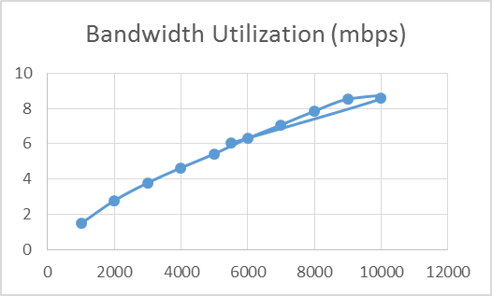
Figure 9.b Bandwidth Utilization in Hybrid Mode

As shown in the figure, the bandwidth utilization will gradually decrease on the cloud server by splitting the requests between the cloud server and the local Raspberry Pi server. Since the load decreases, the latency decreases, giving better bandwidth utilization overall.

Number of Requests | Bandwidth Utilization (mbps) | Number of Requests | Bandwidth Utilization (in mbps)
1000 | 1.48 | 1000 | 2.96
2000 | 2.78 | 2000 | 5.22
3000 | 3.79 | 3000 | 7.02
4000 | 4.64 | 4000 | 8.59
5000 | 5.43 | 5000 | 9.57
6000 | 6.31 | 5500 | 10.28
7000 | 7.07
8000 | 7.85
9000 | 8.53
10000 | 8.56
5500 | 6.04

The proposed model also deals with securing the end-to-end communication in the M2M architecture, by creating an encrypted VPN tunnel between the broker (server) and all the clients participating in the IoT.

Conclusion and future work
The model that our team has proposed is one of the best alternatives to the existing security challenges, secure IoT M2M communication, bring in standardization of security principles to be implemented, authentication of the clients participating in the communication, cost effective security, Is Standalone executable on Windows, Mac OS X, Linux, Android and IOS, has support for simultaneous users, provides Network access control, Authenticating a client-side digital certificate.
The future work includes designing a cross-platform, secure and an highly configurable VPN solution that considers certain potential factors for increasing the performance (like reducing network overhead and having efficient bandwidth), such as payload length, encryption key size, encryption digest, TLS digest, etc. Also in addition to the tests performed, the results should be verified using some analytical modelling of data.
This will help us understand how each of these factors affects the performance and why.

References

[1]Namje Park, Namhi Kang, "Mutual Authentication Scheme in Secure Internet of Things Technology for Comfortable lifestyle
[2] W. Itani, A. Kayssim, A. Chehab, “Privacy as a Service: Privacy-Aware Data Storage and Processing in Cloud
Computing Architectures,” DASC '09 Proceedings of the 2009
Eighth IEEE International Conference on Dependable, Autonomic and Secure Computing, pp. 711-716, 2009.
[3] S. S. Yau, Y. Yin, H. G. An, "An Adaptive Approach to
Optimizing Tradeoff between Service Performance and Security in Service-based Systems," International Journal of Web Services Research, vol. 8, no. 2, pp. 74-91, 2011.
[4] Zhou, L.; Chao, H.-C. Multimedia Trafﬁc Security Architecture for the Internet of Things. IEEE Netw. 2011, 25, 35–40.
[5] Atzori, L.; Iera, A.; Morabito, G. The Internet of Things: A Survey. Comput. Netw. 2010, 54, 2787–2805.
[6]Zhou,L.; Wu,D.; Zheng,B.; Guizani, M.Joint Physical-Application Layer Security for Wireless Multimedia Delivery. IEEE Commun. Mag. 2014, 52, 66–72.
[7]TAROUCO, L. M. R., BERTHOLDO, L. M., GRANVILLE, L. Z., ARBIZA, L. M. R., CARBONE, F., MAROTTA, M.,AND DESANTANNA, J. J. C. Internet of things in health-care: Interoperability and security issues. In Communications (ICC), 2012 IEEE International Conference on (2012), IEEE,pp. 6121–6125.

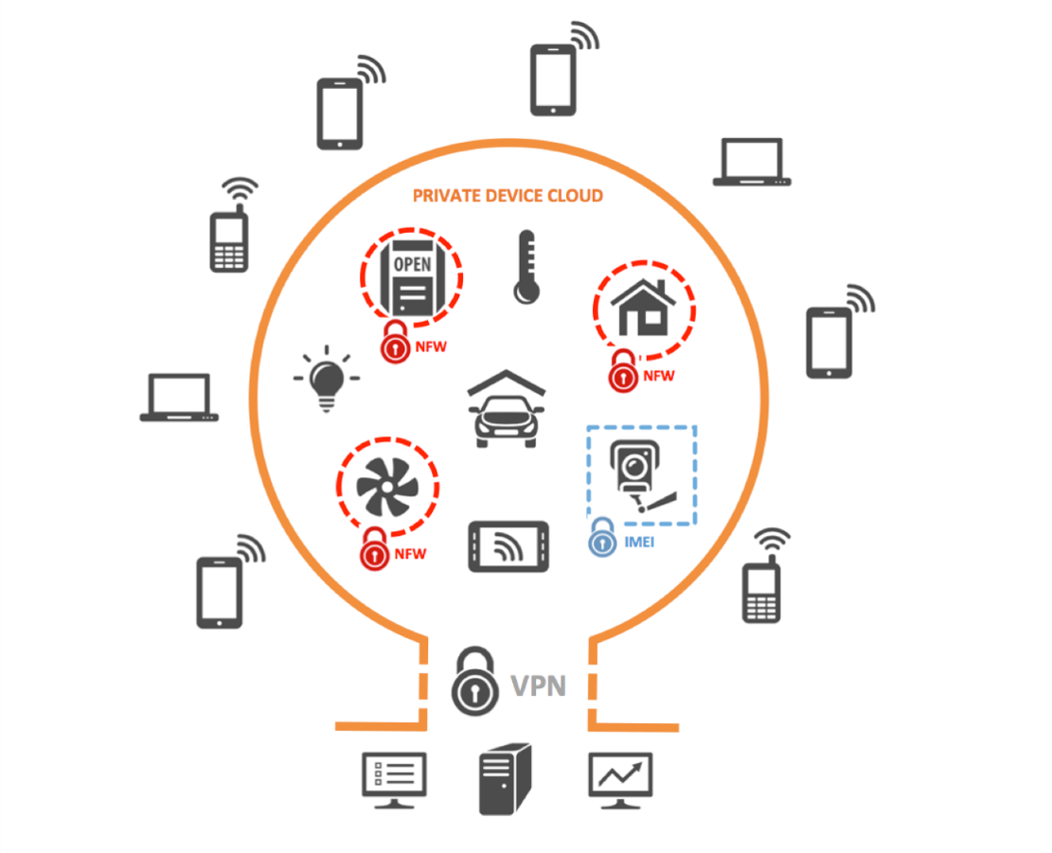

R publisher aeferences
The template will number citations consecutively within brackets [1]. The sentence punctuation follows the bracket [2]. Refer simply to the reference number, as in [3]—do not use “Ref. [3]” or “reference [3]” except at the beginning of a sentence: “Reference [3] was the first ...”
Number footnotes separately in superscripts. Place the actual footnote at the bottom of the column in which it was cited. Do not put footnotes in the reference list. Use letters for table footnotes.
Unless there are six authors or more give all authors’ names; do not use “et al.”. Papers that have not been published, even if they have been submitted for publication, should be cited as “unpublished” [4]. Papers that have been accepted for publication should be cited as “in press” [5]. Capitalize only the first word in a paper title, except for proper nouns and element symbols.
For papers published in translation journals, please give the English citation first, followed by the original foreign-language citation [6].

- G. Eason, B. Noble, and I. N. Sneddon, “On certain integrals of Lipschitz-Hankel type involving products of Bessel functions,” Phil. Trans. Roy. Soc. London, vol. A247, pp. 529–551, April 1955. (references)
We suggest that you use a text box to insert a graphic (which is ideally a 300 dpi TIFF or EPS file, with all fonts embedded) because, in an MSW document, this method is somewhat more stable than directly inserting a picture.
To have non-visible rules on your frame, use the MSWord “Format” pull-down menu, select Text Box > Colors and Lines to choose No Fill and No Line.
- J. Clerk Maxwell, A Treatise on Electricity and Magnetism, 3rd ed., vol. 2. Oxford: Clarendon, 1892, pp.68–73.
- I. S. Jacobs and C. P. Bean, “Fine particles, thin films and exchange anisotropy,” in Magnetism, vol. III, G. T. Rado and H. Suhl, Eds. New York: Academic, 1963, pp. 271–350.
- K. Elissa, “Title of paper if known,” unpublished.
- R. Nicole, “Title of paper with only first word capitalized,” J. Name Stand. Abbrev., in press.
- Y. Yorozu, M. Hirano, K. Oka, and Y. Tagawa, “Electron spectroscopy studies on magneto-optical media and plastic substrate interface,” IEEE Transl. J. Magn. Japan, vol. 2, pp. 740–741, August 1987 [Digests 9th Annual Conf. Magnetics Japan, p. 301, 1982].
- M. Young, The Technical Writer’s Handbook. Mill Valley, CA: University Science, 1989.

